**Exercise 1: Mocking and Stubbing**

**Code:**

**Interface ExternalApi.java-**

package org.example;  
  
public interface ExternalApi {  
 String getData();  
}

**Class MyService.java –**

package org.example;  
  
public class MyService {  
 private ExternalApi externalApi;  
  
 public MyService(ExternalApi externalApi) {  
 this.externalApi = externalApi;  
 }  
  
 public String fetchData() {  
 return externalApi.getData();  
 }  
}

**Test Class MyServiceTest.java –**

import static org.mockito.Mockito.*;  
import org.example.ExternalApi;  
import org.example.MyService;  
import org.junit.jupiter.api.Assertions;  
import org.junit.jupiter.api.Test;  
import org.mockito.Mockito;  
  
public class MyServiceTest {  
  
 @Test  
 public void testExternalApi() {  
  
 ExternalApi mockApi = Mockito.*mock*(ExternalApi.class);  
  
 *when*(mockApi.getData()).thenReturn("Mock Data");  
  
 MyService service = new MyService(mockApi);  
 String result = service.fetchData();  
  
 Assertions.*assertEquals*("Mock Data", result);  
  
 *verify*(mockApi).getData();  
 }  
}

**OUTPUT:**

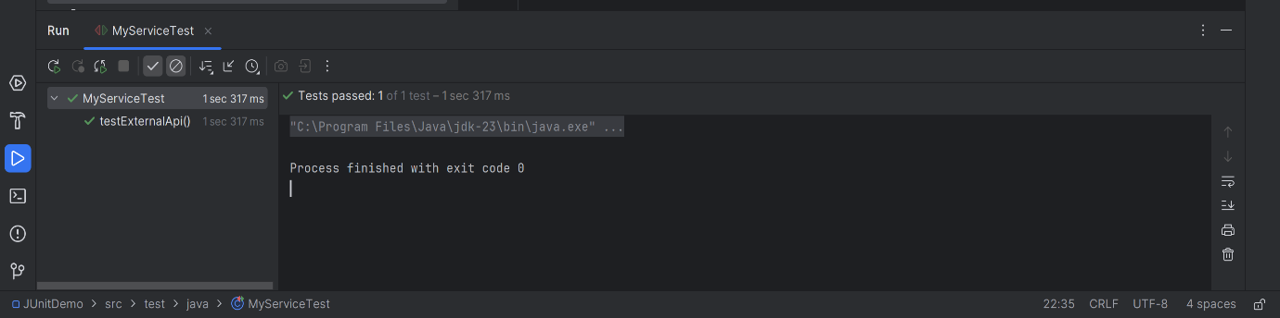

**EXERCISE 2: Verifying Interactions**

**Code:**

**Interface ExternalApi.java-**

package org.example;  
  
public interface ExternalApi {  
 String getData(String userId);  
}

**Class MyService.java-**

package org.example;  
  
public class MyService {  
 private ExternalApi externalApi;  
  
 public MyService(ExternalApi externalApi) {  
 this.externalApi = externalApi;  
 }  
  
 public void fetchData(String userId) {  
 externalApi.getData(userId);  
 }  
}

**Test class MyServiceTest.java –**

import static org.mockito.Mockito.*;  
import org.example.ExternalApi;  
import org.example.MyService;  
import org.junit.jupiter.api.Test;  
import org.mockito.Mockito;  
  
public class MyServiceTest {  
  
 @Test  
 public void testVerifyInteraction() {  
  
 ExternalApi mockApi = Mockito.*mock*(ExternalApi.class);  
  
 MyService service = new MyService(mockApi);  
  
 service.fetchData("user123");  
  
 *verify*(mockApi).getData("user123");  
 }  
}

**OUTPUT:**

